Polygon–Freeform Closed Shapes
# Source: AI Source: Provided by: [Data Path: Persons Table -> ID Column: 1, Name_En Column: Motasem Essam] -> From: [ChatGPT] on [7/25/2026]
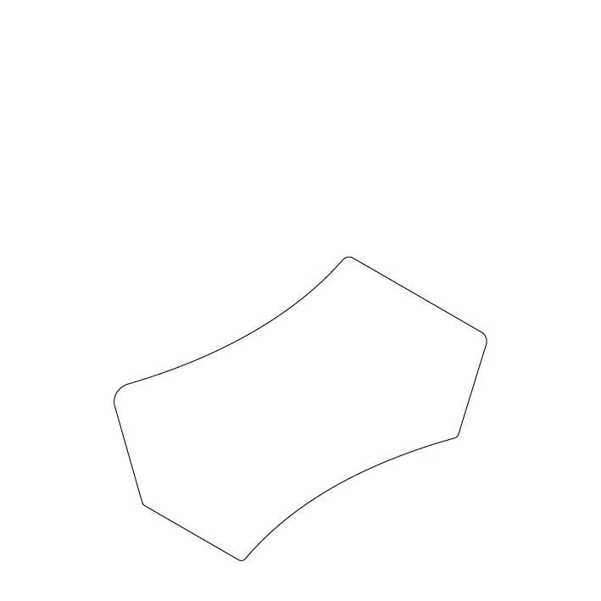
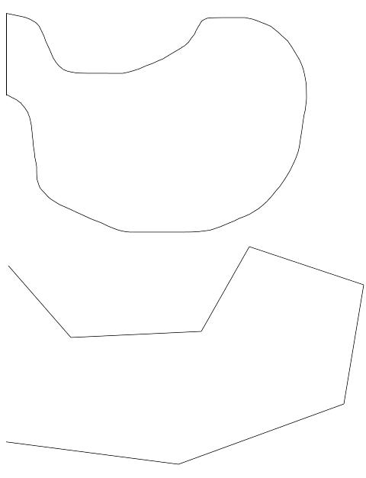
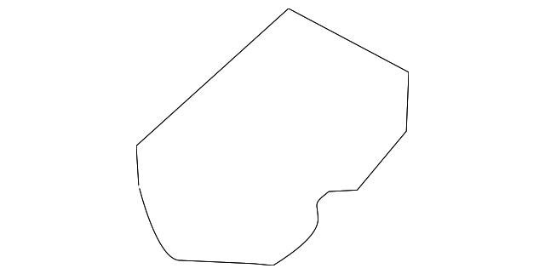

Definition
# Source: AI Source: Provided by: [Data Path: Persons Table -> ID Column: 1, Name_En Column: Motasem Essam] -> From: [ChatGPT] on [7/25/2026]
A Polygon–Freeform Closed Shape is a closed mixed shape whose boundary combines straight polygonal segments with freely designed curved segments.
$$\boxed{\text{Polygon–Freeform Closed Shape}=\text{Polygonal Segments}+\text{Freeform Curves}+\text{Closed Boundary}}$$
The curved portions are not required to be circular, elliptical, or another standard geometric curve.

Characteristics
# Source: AI Source: Provided by: [Data Path: Persons Table -> ID Column: 1, Name_En Column: Motasem Essam] -> From: [ChatGPT] on [7/25/2026]
A Polygon–Freeform Closed Shape:
- Is closed.
- Encloses a bounded region.
- Contains at least one straight polygonal segment.
- Contains at least one freeform curved segment.
- Has no requirement for the curved portion to follow a standard equation.
- May be symmetric or asymmetric.
- May be regular-looking or irregular.
- Can be designed manually, with Bézier curves, splines, CAD tools, or vector graphics.

Types of Polygon–Freeform Closed Shapes

1. Triangle–Freeform Closed Shapes
# Source: AI Source: Provided by: [Data Path: Persons Table -> ID Column: 1, Name_En Column: Motasem Essam] -> From: [ChatGPT] on [7/25/2026]
A triangular component combined with one or more freely designed curves.
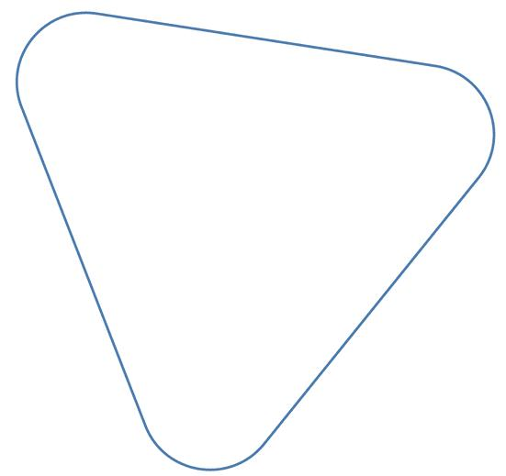
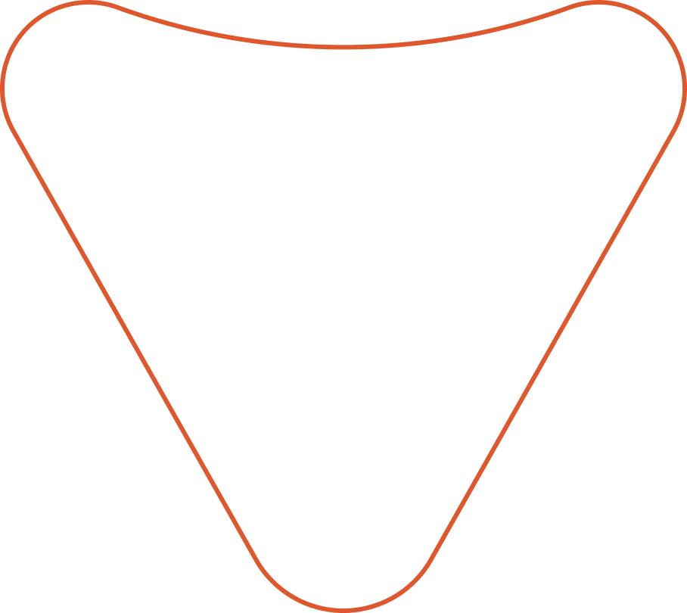
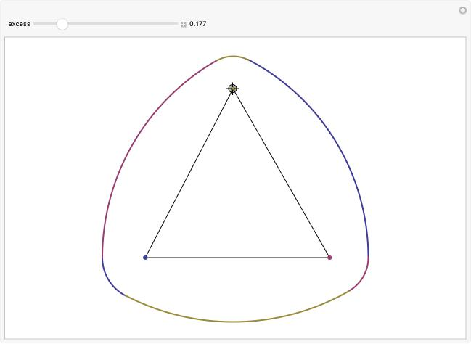
$$\boxed{\text{Triangle}+\text{Freeform Curve}}$$

2. Quadrilateral–Freeform Closed Shapes
# Source: AI Source: Provided by: [Data Path: Persons Table -> ID Column: 1, Name_En Column: Motasem Essam] -> From: [ChatGPT] on [7/25/2026]
A quadrilateral component combined with freely controlled curved boundaries.
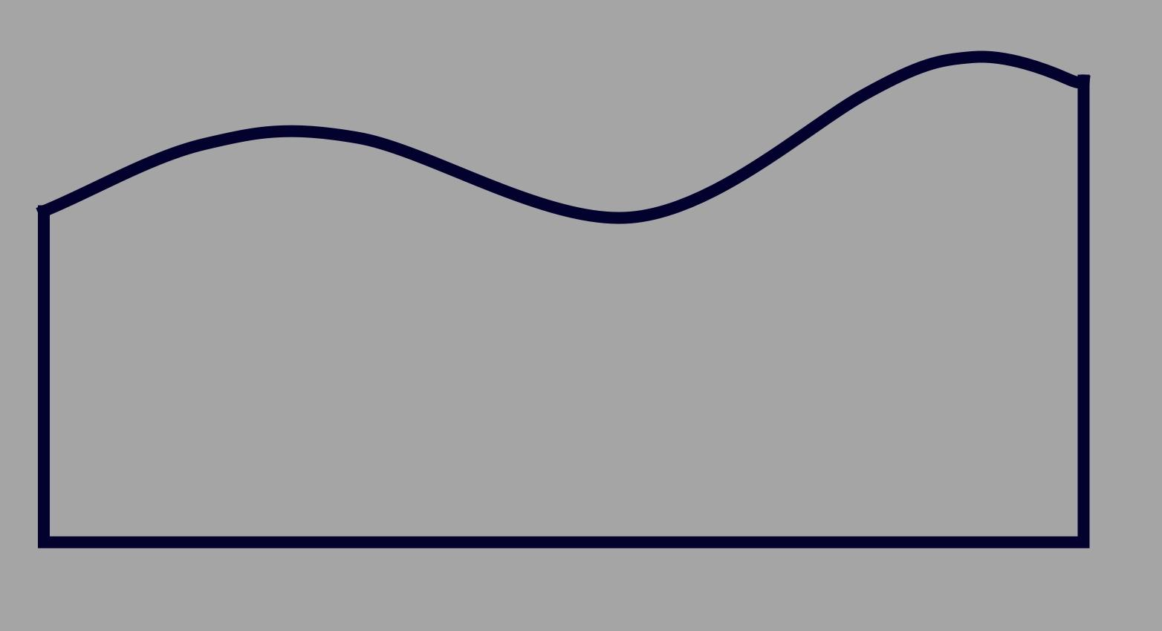
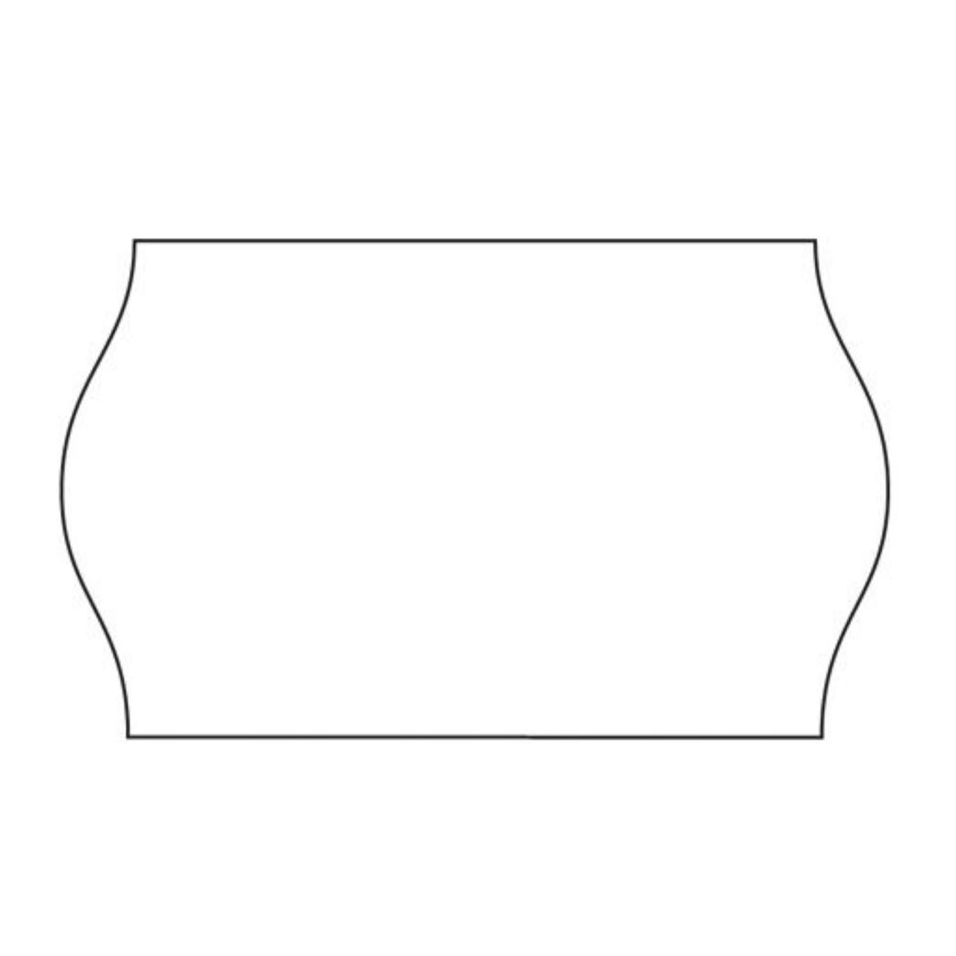
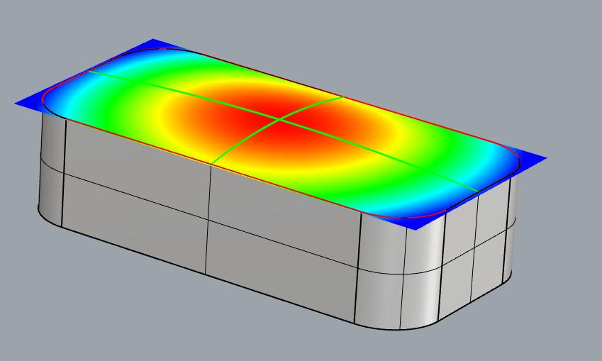
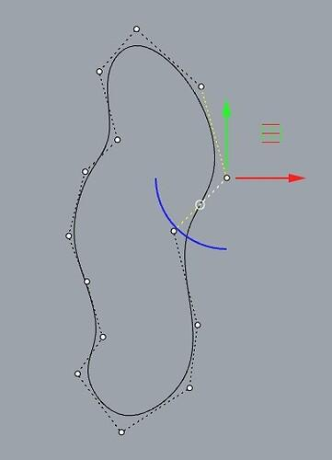
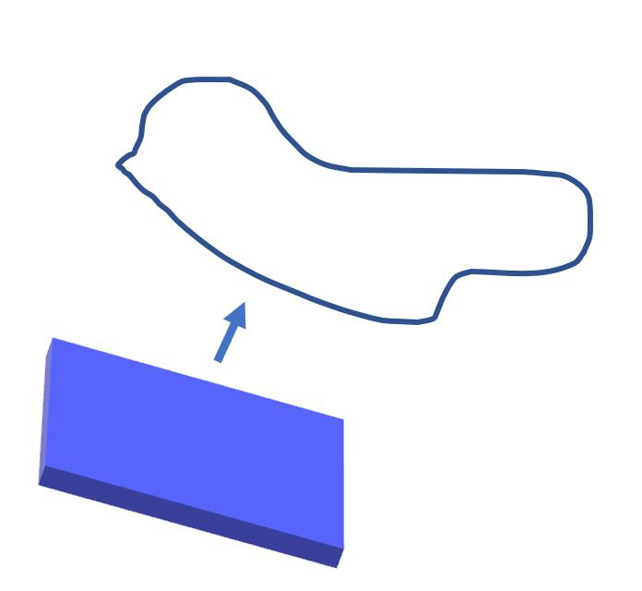
The straight portions may come from a rectangle, trapezoid, or other quadrilateral.

3. Pentagon–Freeform Closed Shapes
# Source: AI Source: Provided by: [Data Path: Persons Table -> ID Column: 1, Name_En Column: Motasem Essam] -> From: [ChatGPT] on [7/25/2026]
A pentagonal component combined with freeform curves.
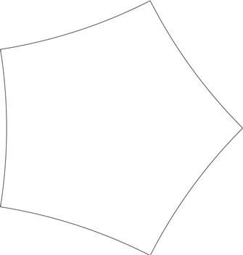
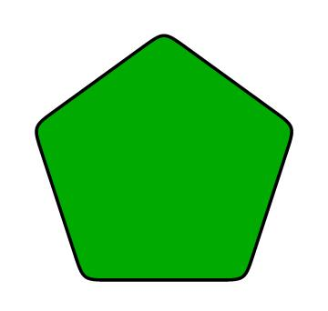

4. Hexagon–Freeform Closed Shapes
# Source: AI Source: Provided by: [Data Path: Persons Table -> ID Column: 1, Name_En Column: Motasem Essam] -> From: [ChatGPT] on [7/25/2026]
A hexagonal component combined with one or more freely designed curves.
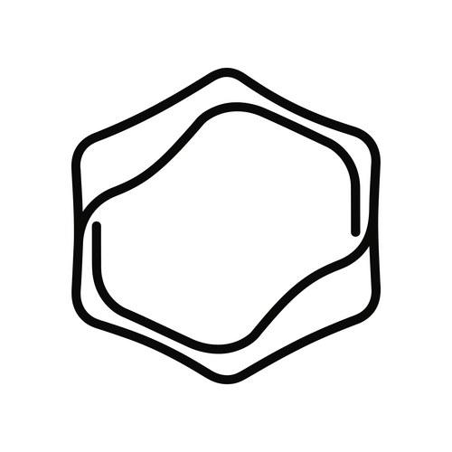
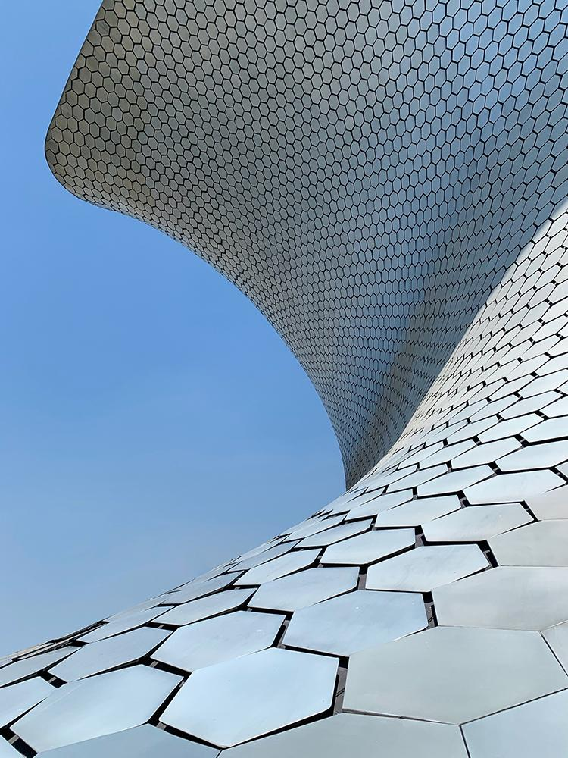
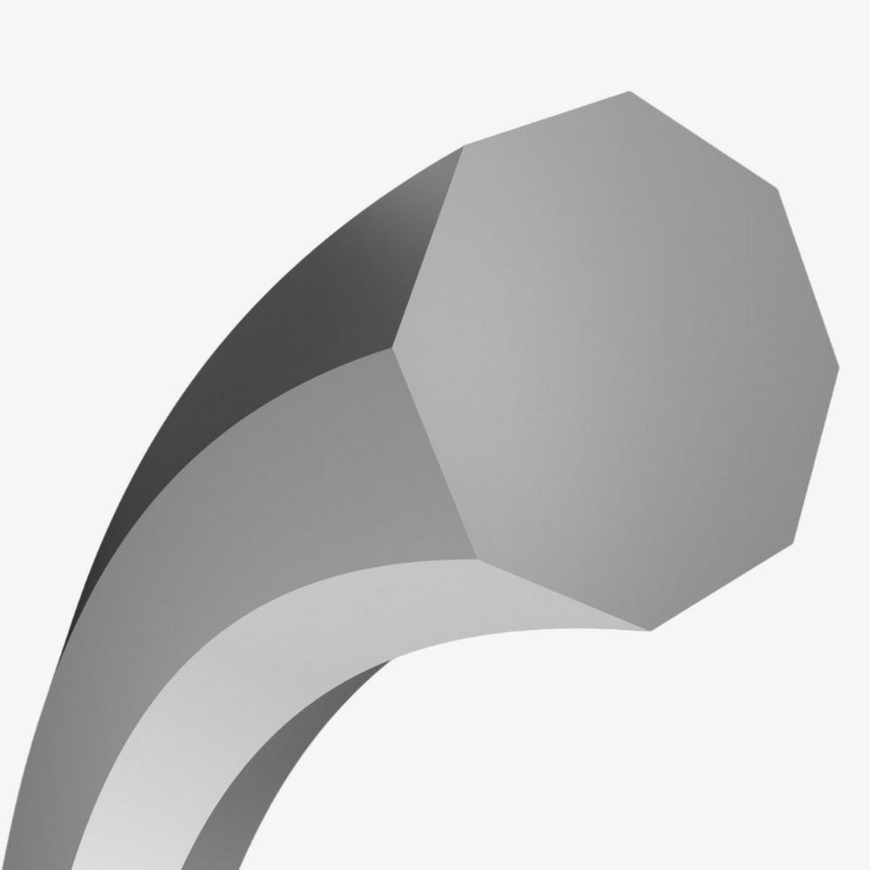

5. Polygon with Freeform Bulges
# Source: AI Source: Provided by: [Data Path: Persons Table -> ID Column: 1, Name_En Column: Motasem Essam] -> From: [ChatGPT] on [7/25/2026]
A polygonal boundary containing rounded, freely controlled protrusions.
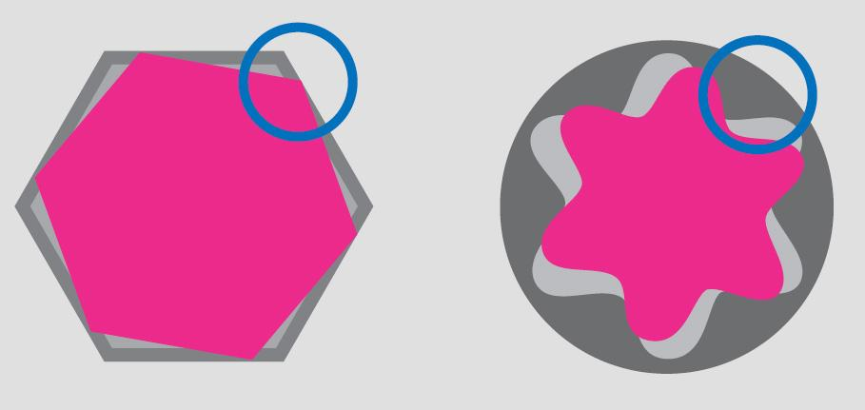
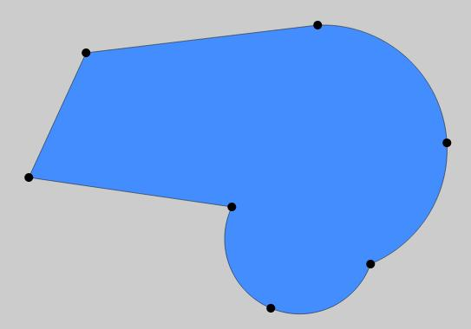
The bulges are not necessarily circular arcs.

6. Polygon with Freeform Indentations
# Source: AI Source: Provided by: [Data Path: Persons Table -> ID Column: 1, Name_En Column: Motasem Essam] -> From: [ChatGPT] on [7/25/2026]
A polygonal shape containing inward freeform curves.
Depending on the arrangement, the overall shape may be convex or concave.

7. Polygon–Bézier Closed Shapes
# Source: AI Source: Provided by: [Data Path: Persons Table -> ID Column: 1, Name_En Column: Motasem Essam] -> From: [ChatGPT] on [7/25/2026]
The freeform portion is created using Bézier curve segments.
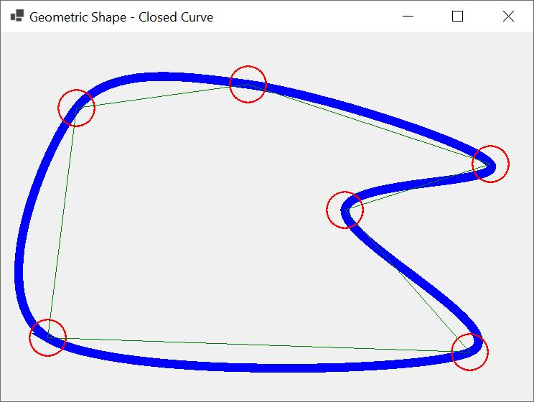
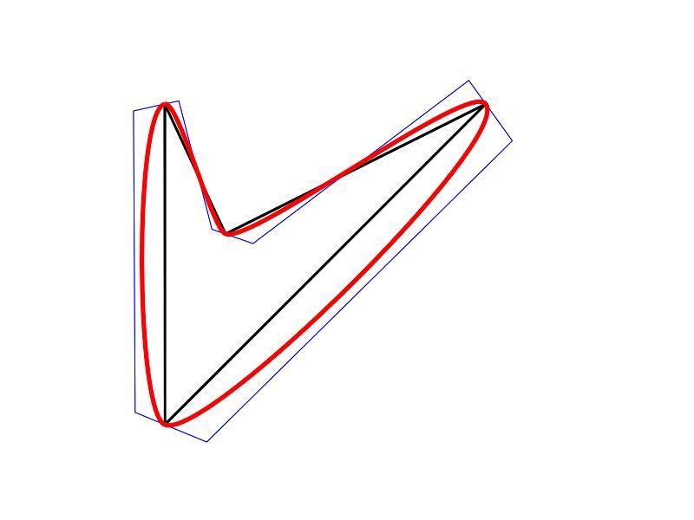
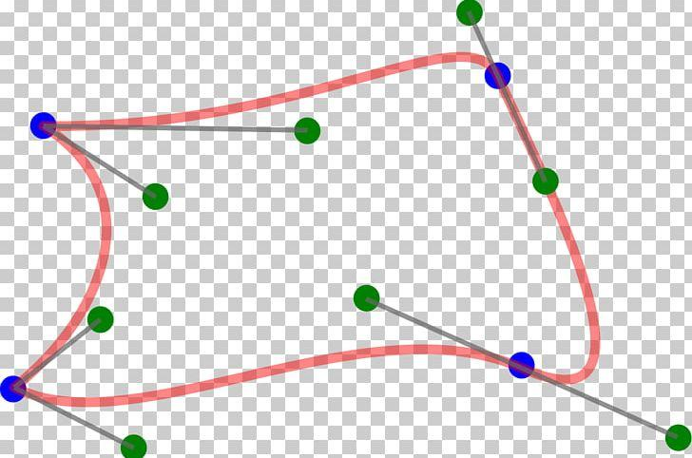
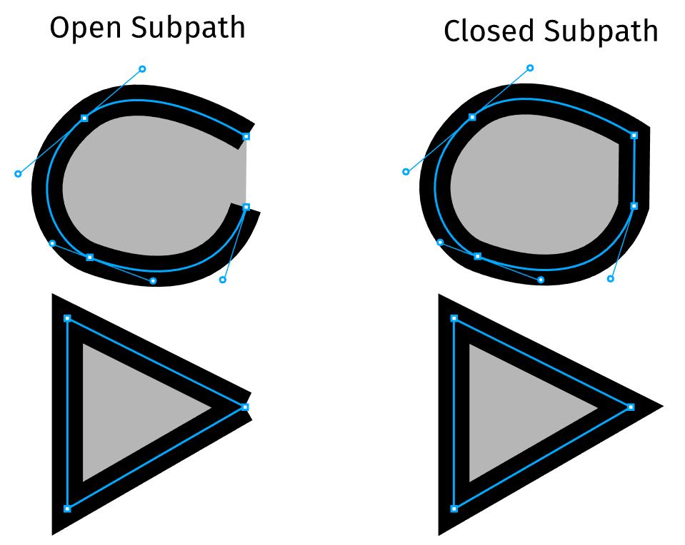
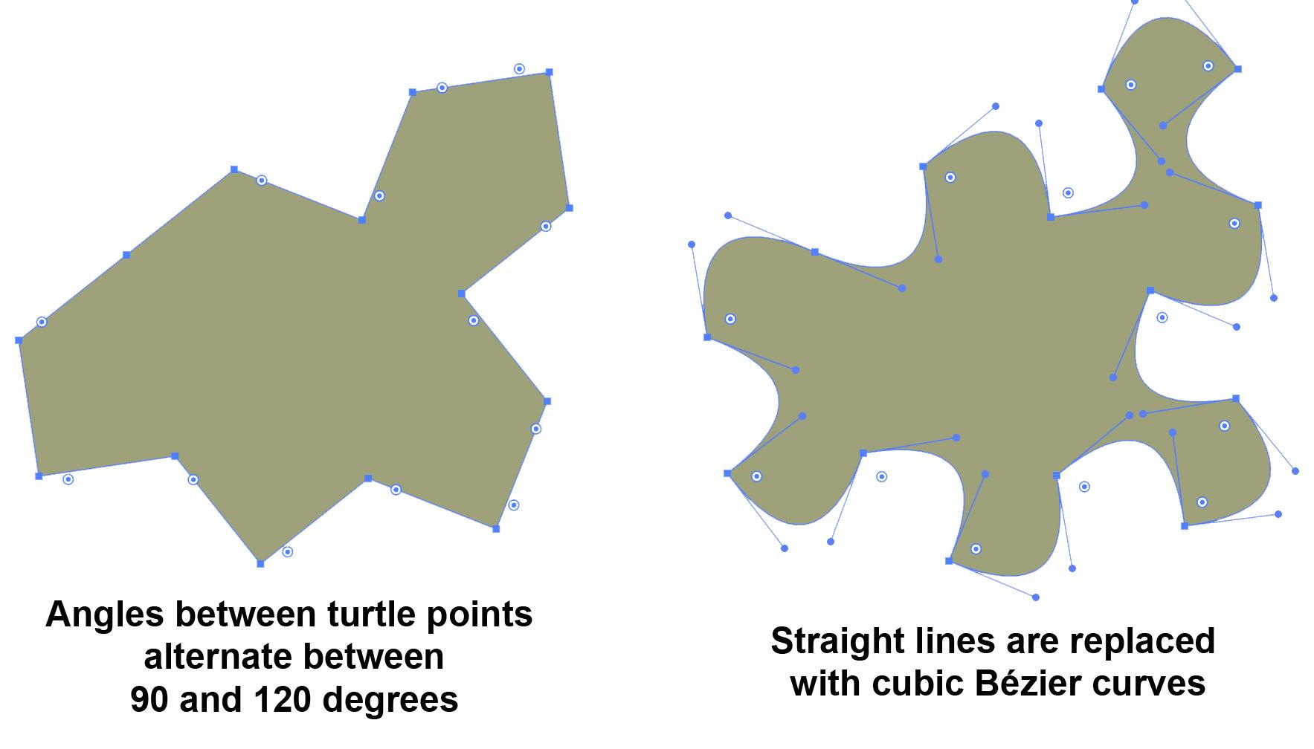
A Bézier segment can be represented by:
$$B\left(t\right)={\left(1-t\right)}^{3}P_{0}+3{\left(1-t\right)}^{2}tP_{1}+3\left(1-t\right)t^{2}P_{2}+t^{3}P_{3}$$
Multiple segments can be connected with polygonal segments to form a closed boundary.

8. Polygon–Spline Closed Shapes
# Source: AI Source: Provided by: [Data Path: Persons Table -> ID Column: 1, Name_En Column: Motasem Essam] -> From: [ChatGPT] on [7/25/2026]
A spline is used to create smooth freeform portions.
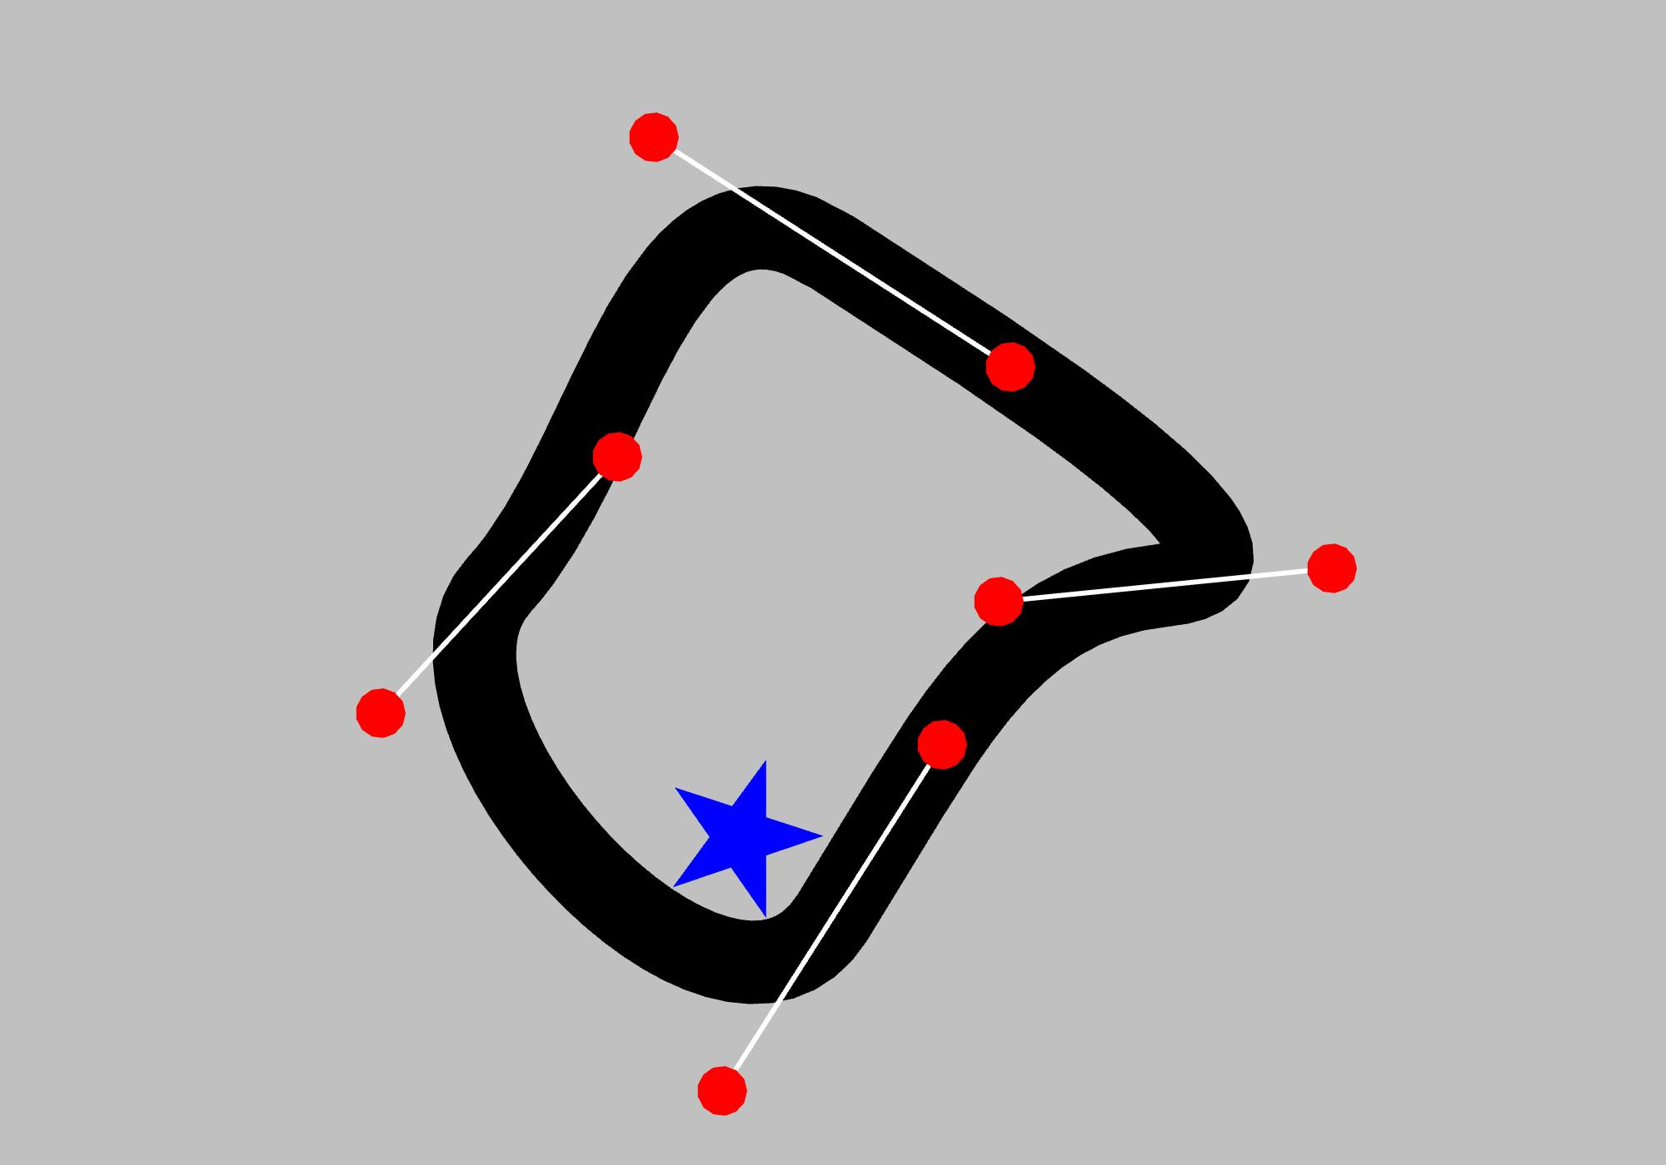
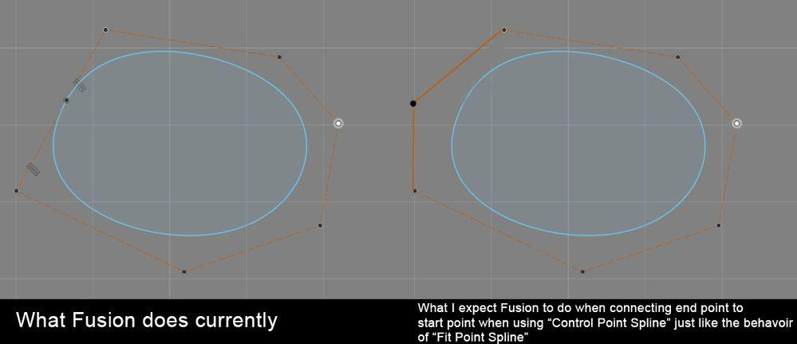
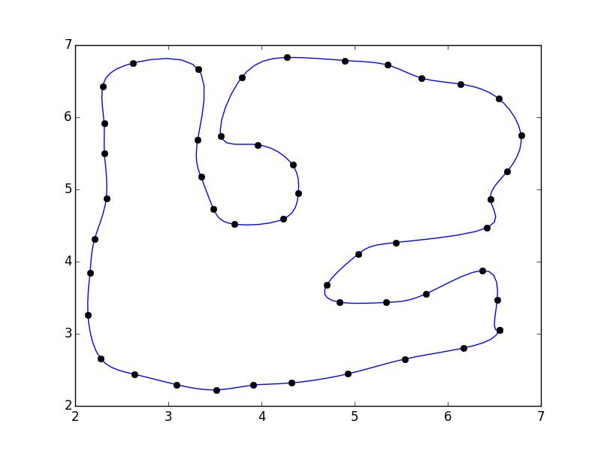
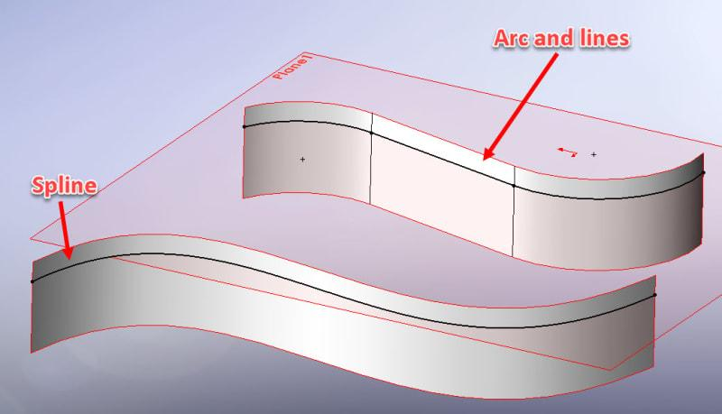
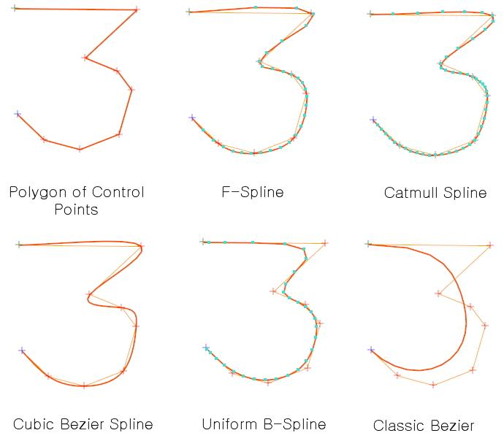
This is common in:
- CAD.
- Product design.
- Computer graphics.
- Industrial design.

9. Asymmetric Polygon–Freeform Closed Shapes
# Source: AI Source: Provided by: [Data Path: Persons Table -> ID Column: 1, Name_En Column: Motasem Essam] -> From: [ChatGPT] on [7/25/2026]
The polygonal and curved portions are arranged without regular symmetry.
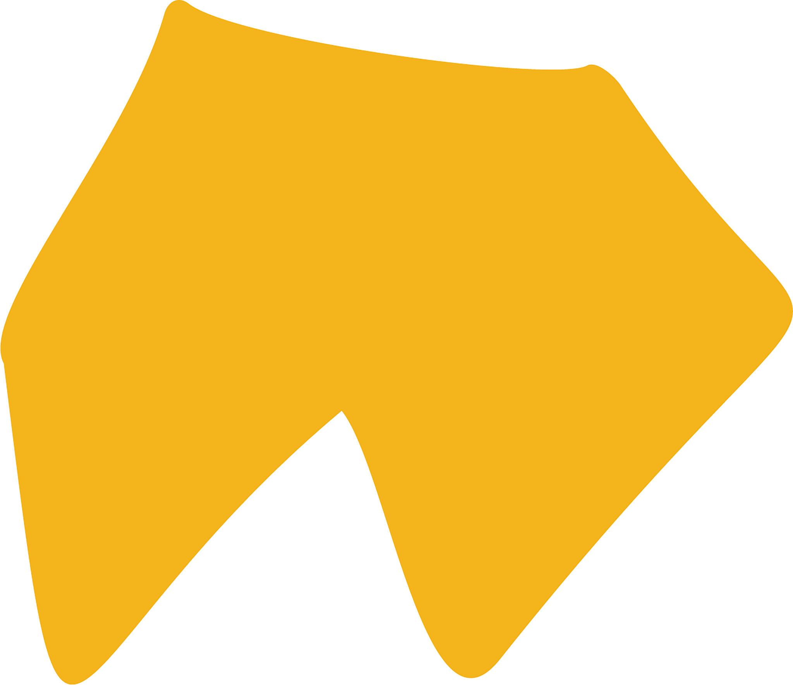
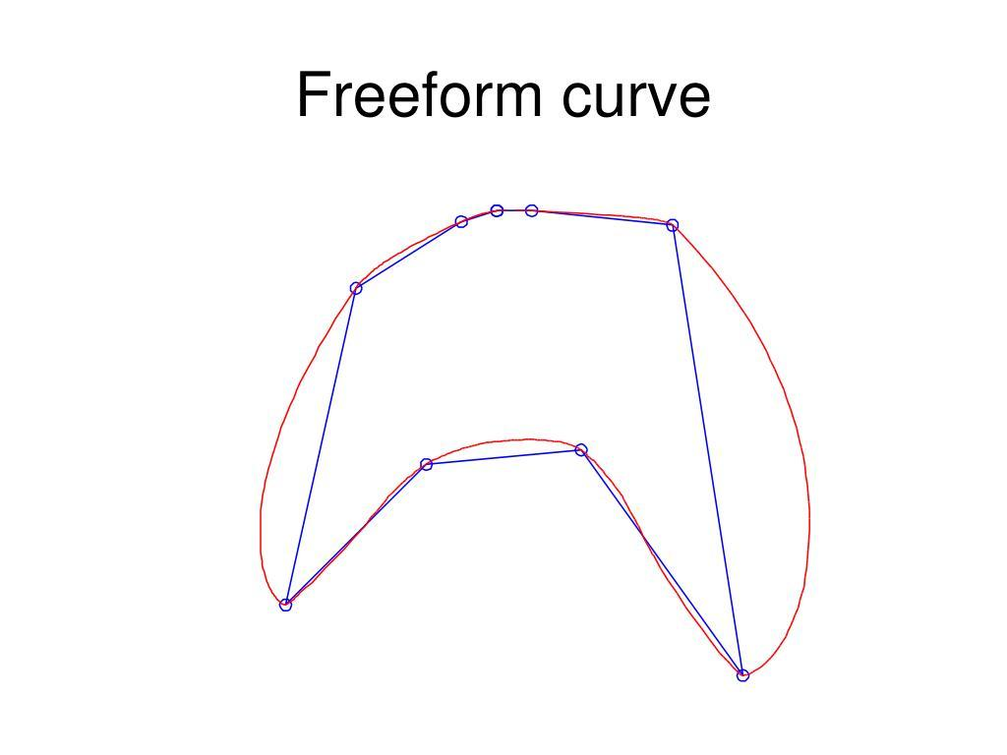
Different sides and curves may have different:
- Lengths.
- Curvatures.
- Angles.
- Widths.
- Positions.

10. Symmetric Polygon–Freeform Closed Shapes
# Source: AI Source: Provided by: [Data Path: Persons Table -> ID Column: 1, Name_En Column: Motasem Essam] -> From: [ChatGPT] on [7/25/2026]
The curved portions are freely designed but arranged with symmetry.
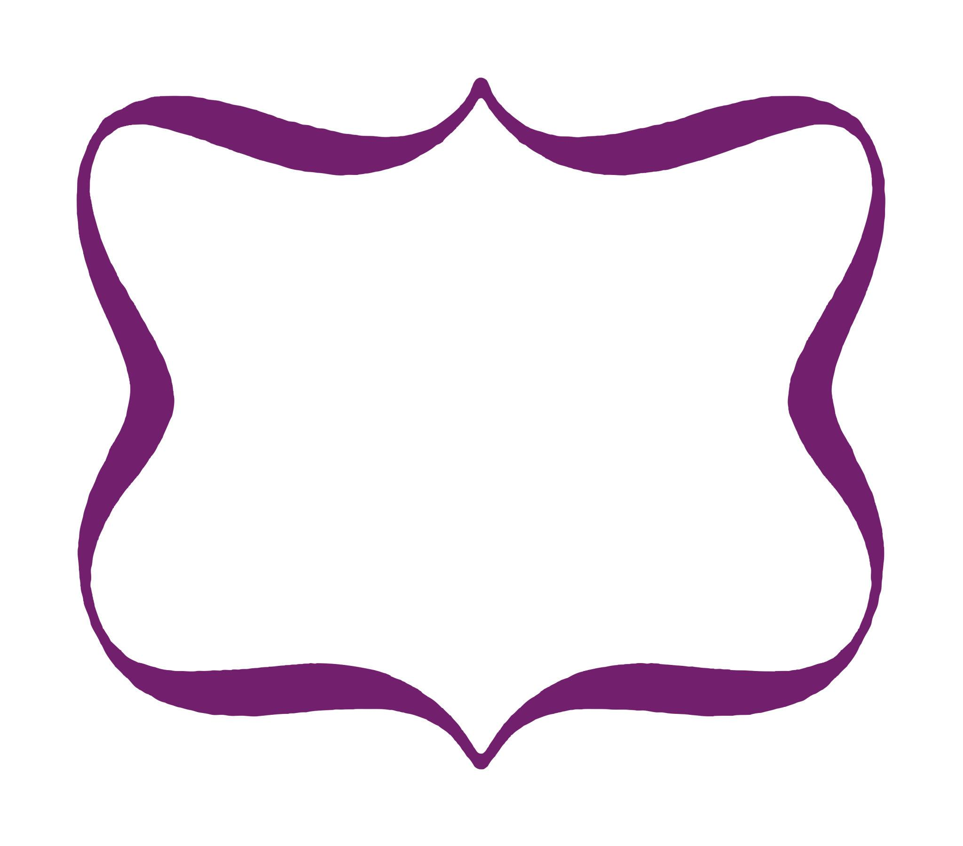
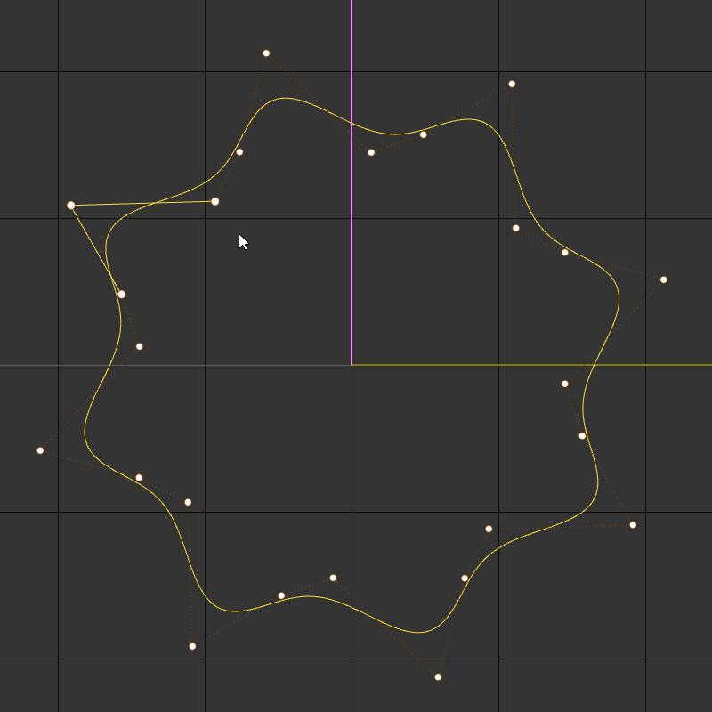
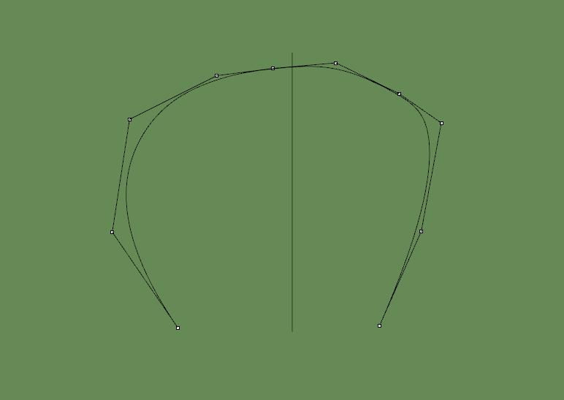
This demonstrates an important distinction:
$$\boxed{\text{Freeform does not necessarily mean asymmetric}}$$
A curve can be freely designed while still being symmetric.

Polygon–Freeform vs. Polygon–Circular
# Source: AI Source: Provided by: [Data Path: Persons Table -> ID Column: 1, Name_En Column: Motasem Essam] -> From: [ChatGPT] on [7/25/2026]
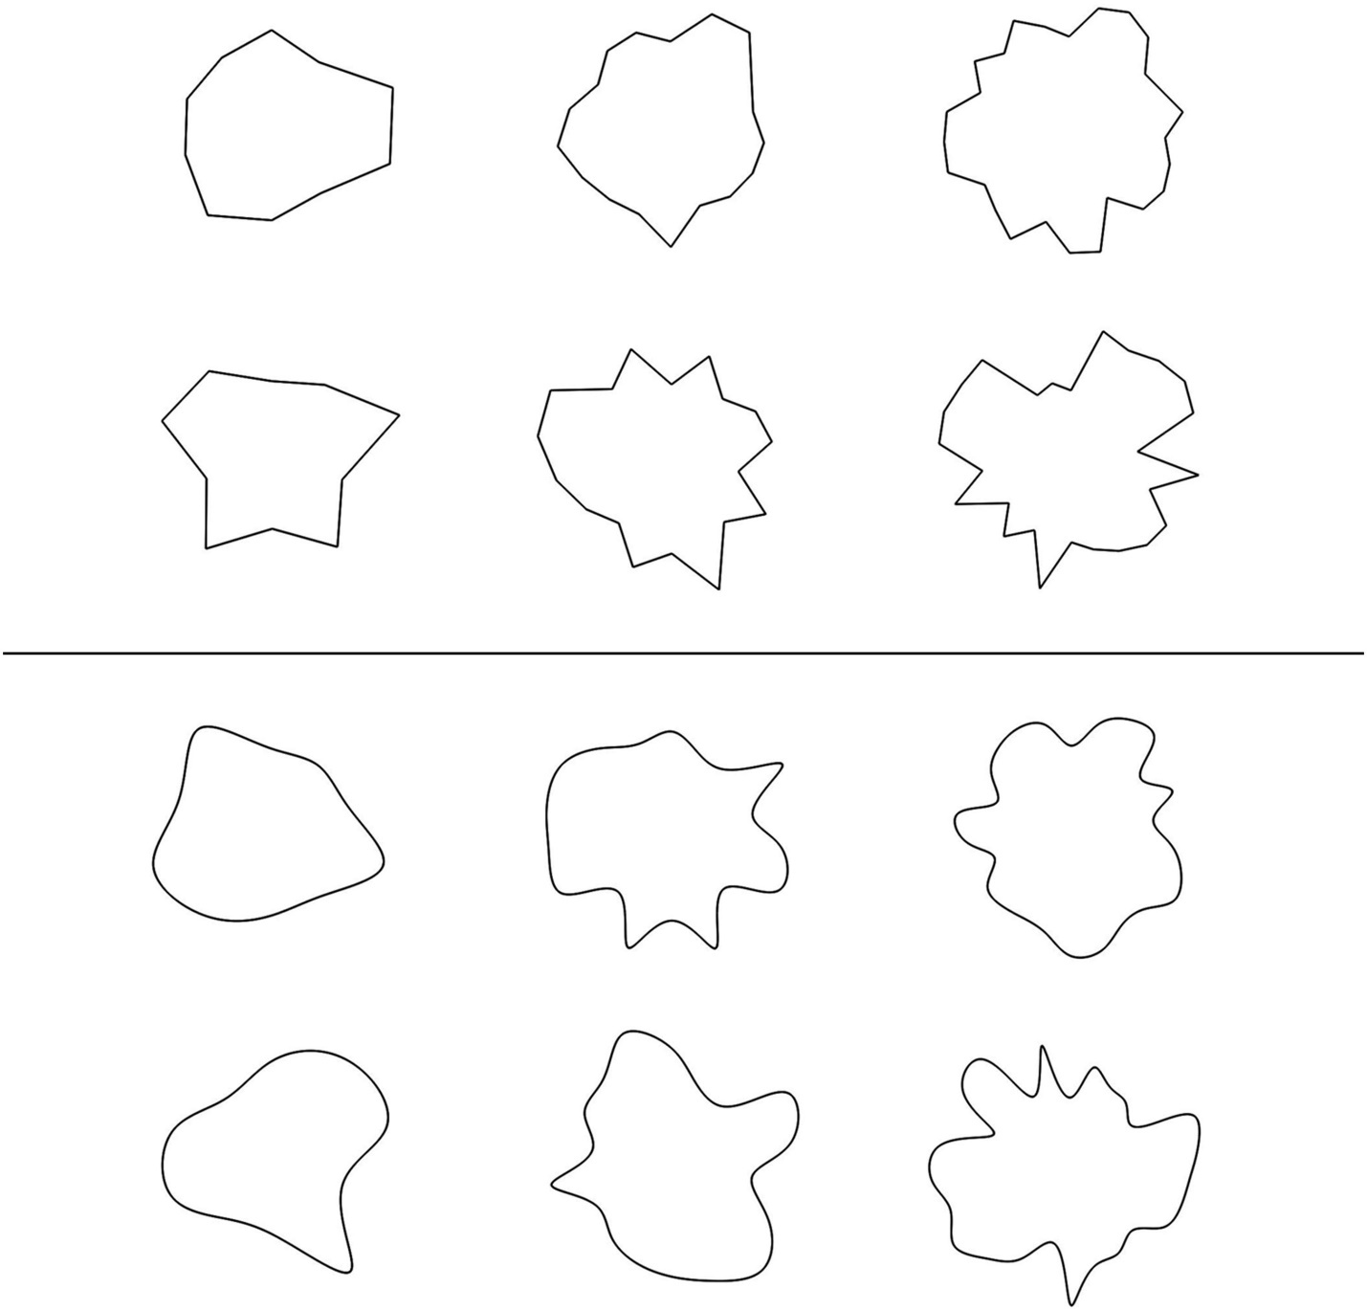
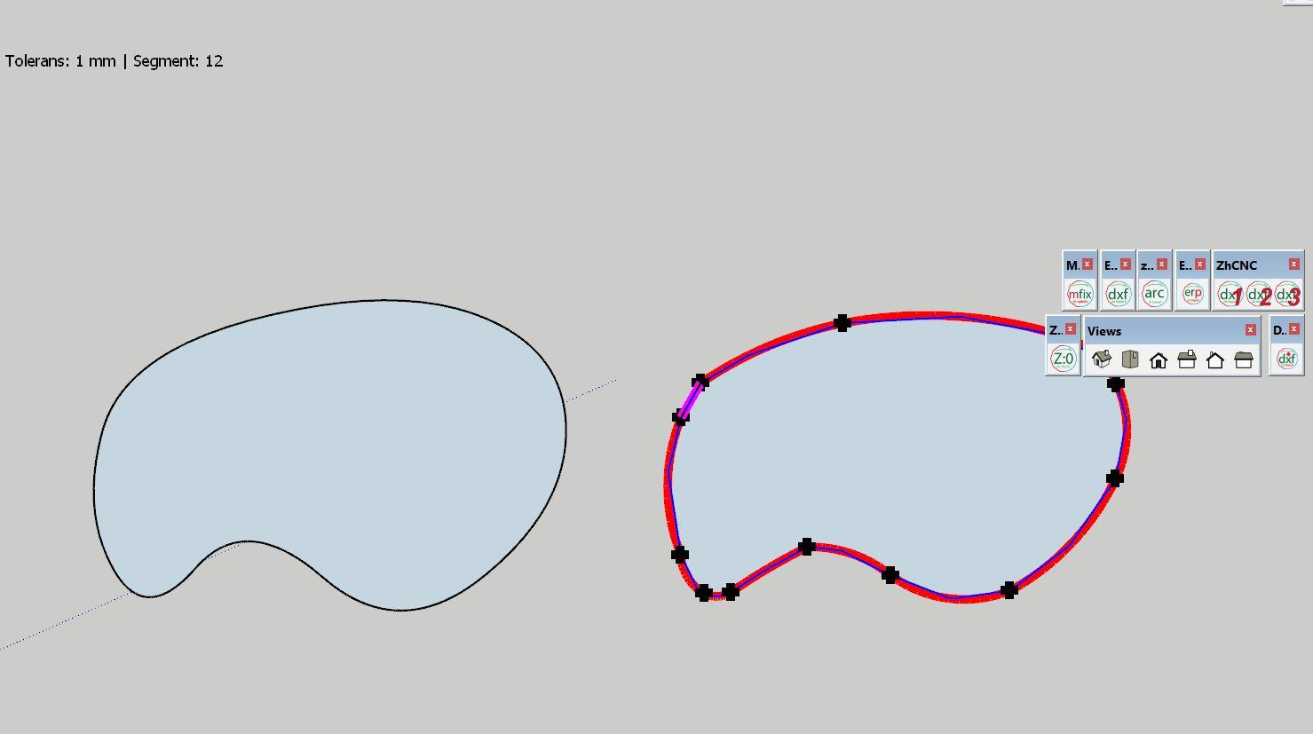
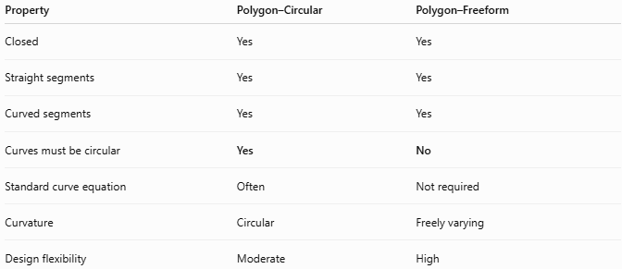
Property | Polygon–Circular | Polygon–Freeform
Closed | Yes | Yes
Straight segments | Yes | Yes
Curved segments | Yes | Yes
Curves must be circular | Yes | No
Standard curve equation | Often | Not required
Curvature | Circular | Freely varying
Design flexibility | Moderate | High
The main distinction is:
$$\boxed{\text{Circular Curve}=\text{Specific Geometric Constraint}}$$
while:
$$\boxed{\text{Freeform Curve}=\text{No Specific Standard Curve Required}}$$

Polygon–Freeform vs. Polygon–Organic
# Source: AI Source: Provided by: [Data Path: Persons Table -> ID Column: 1, Name_En Column: Motasem Essam] -> From: [ChatGPT] on [7/25/2026]
These two categories can overlap.
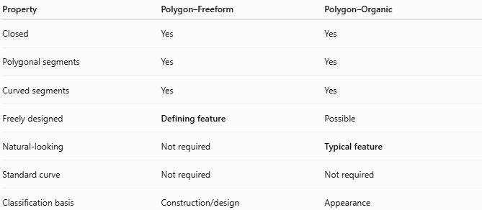
Property | Polygon–Freeform | Polygon–Organic
Closed | Yes | Yes
Polygonal segments | Yes | Yes
Curved segments | Yes | Yes
Freely designed | Defining feature | Possible
Natural-looking | Not required | Typical feature
Standard curve | Not required | Not required
Classification basis | Construction/design | Appearance
For example, a digitally designed leaf-like shape containing a straight edge can be both:
$$\boxed{\text{Polygon–Freeform}+\text{Polygon–Organic}}$$

Polygon–Freeform vs. Pure Freeform Closed Shapes
# Source: AI Source: Provided by: [Data Path: Persons Table -> ID Column: 1, Name_En Column: Motasem Essam] -> From: [ChatGPT] on [7/25/2026]
The difference is the presence of straight polygonal segments.
$$\boxed{\text{Polygon–Freeform}=\text{Straight}+\text{Curved}}$$
whereas:
$$\boxed{\text{Pure Freeform Curved}=\text{Curved Boundary Only}}$$

Area
# Source: AI Source: Provided by: [Data Path: Persons Table -> ID Column: 1, Name_En Column: Motasem Essam] -> From: [ChatGPT] on [7/25/2026]
Because the shape is closed, it encloses a region.
Its area can be calculated by decomposition:
$$\boxed{A_{\text{total}}=A_{\text{polygonal portions}}±A_{\text{freeform portions}}}$$
For simple freeform curves, numerical methods or CAD software may be used.
For a parametric closed curve:
$$x=x\left(t\right), y=y\left(t\right)$$
the curved portion can be evaluated using:
$$\boxed{A=\frac{1}{2}\oint{\left(x,dy-y,dx\right)}}$$
when applied to the complete closed boundary.

Perimeter
# Source: AI Source: Provided by: [Data Path: Persons Table -> ID Column: 1, Name_En Column: Motasem Essam] -> From: [ChatGPT] on [7/25/2026]
The perimeter consists of both straight and curved sections:
$$\boxed{P=L_{\text{straight}}+L_{\text{freeform}}}$$
Straight sections use ordinary distance formulas, while freeform sections use arc-length calculations or numerical measurement.

Key Points
# Source: AI Source: Provided by: [Data Path: Persons Table -> ID Column: 1, Name_En Column: Motasem Essam] -> From: [ChatGPT] on [7/25/2026]
A Polygon–Freeform Closed Shape is:
$$\boxed{\text{Closed}+\text{Straight Polygonal Segments}+\text{Freely Designed Curves}}$$
It:
- Has a closed boundary.
- Contains straight polygonal portions.
- Contains freeform curved portions.
- Does not require the curves to be circular.
- Can be convex or concave.
- Can be symmetric or asymmetric.
- Can be regular-looking or irregular.
- Can be created using Bézier curves, splines, CAD, or freehand/vector methods.

Conclusion
# Source: AI Source: Provided by: [Data Path: Persons Table -> ID Column: 1, Name_En Column: Motasem Essam] -> From: [ChatGPT] on [7/25/2026]
Polygon–Freeform Closed Shapes are closed mixed shapes that combine polygonal straight segments with freely designed curved portions. Unlike Polygon–Circular Shapes, their curved portions do not have to follow a circular geometry. They can be Bézier-based, spline-based, asymmetric, symmetric, bulged, indented, or combined with different polygon types.

